**1.Update or Retrieve Your Password: Keep Your Account Secure by Changing or Resetting Your Password Whenever Needed.**

When you find yourself needing to update or retrieve your password, whether due to a forgotten password or the need for a security update, there's a straightforward process in place to assist you. This service is available to all employees to ensure the security of their accounts and access to essential HRMS features.

1. Contact HR for Assistance: If you're unable to access your account due to a forgotten password or if you need to update it for security reasons, simply reach out to the HR department through phone, messaging, or in-person communication.



2. Provide Your Full Employee Name: During your communication with HR, be sure to provide your full employee name for verification purposes. This helps ensure that the password reset process is secure and authorized.

3. Receive Password Reset Link: Upon verifying your identity, HR will initiate the password reset process. You will receive an email containing a secure link to a form where you can reset your password.

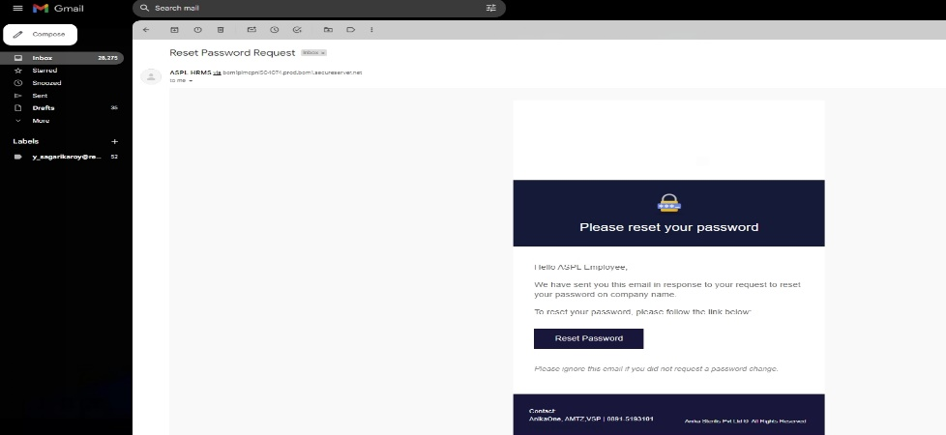

4. Follow the Instructions in the Email: Open the email and click on the provided link to access the password reset form. Follow the instructions carefully to reset your password securely.

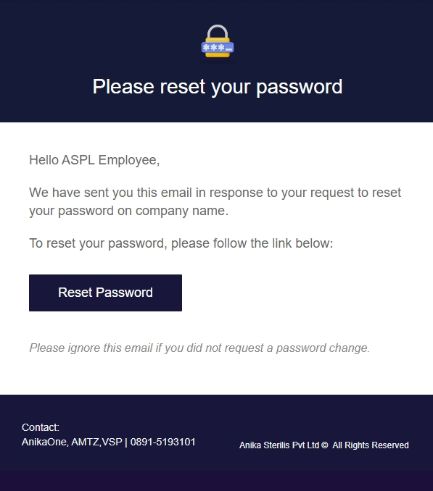

5. Set Your New Password: In the password reset form, you'll be prompted to enter a new password. Choose a strong and memorable password to enhance the security of your account.

6. Confirm Password Update: Once you've entered your new password, confirm the update as instructed in the form. This final step ensures that your password is successfully updated in the system.

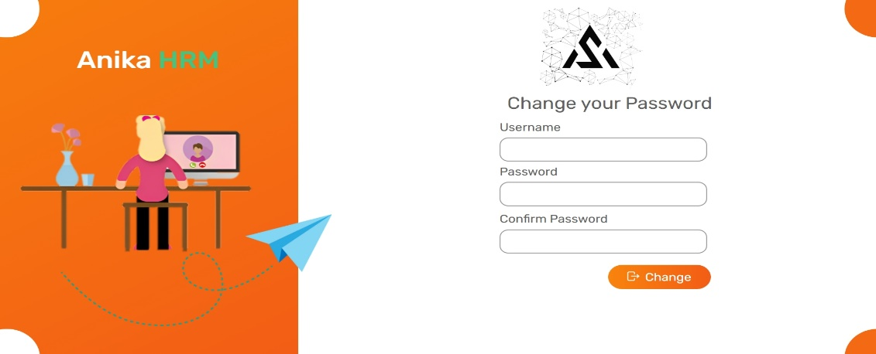

By following these steps, you can easily update or retrieve your password with the assistance of the HR department, ensuring secure access to your HRMS account.

**2. Explore Your Dashboard: Get a Comprehensive Tour of Your Dashboard Layout and Features to Maximize Efficiency in Managing Your HR Tasks.**

When it comes to navigating your dashboard, it's essential to understand its layout and the wealth of information it offers at your fingertips. Here's a breakdown of what you can expect to find and how to make the most out of each section:

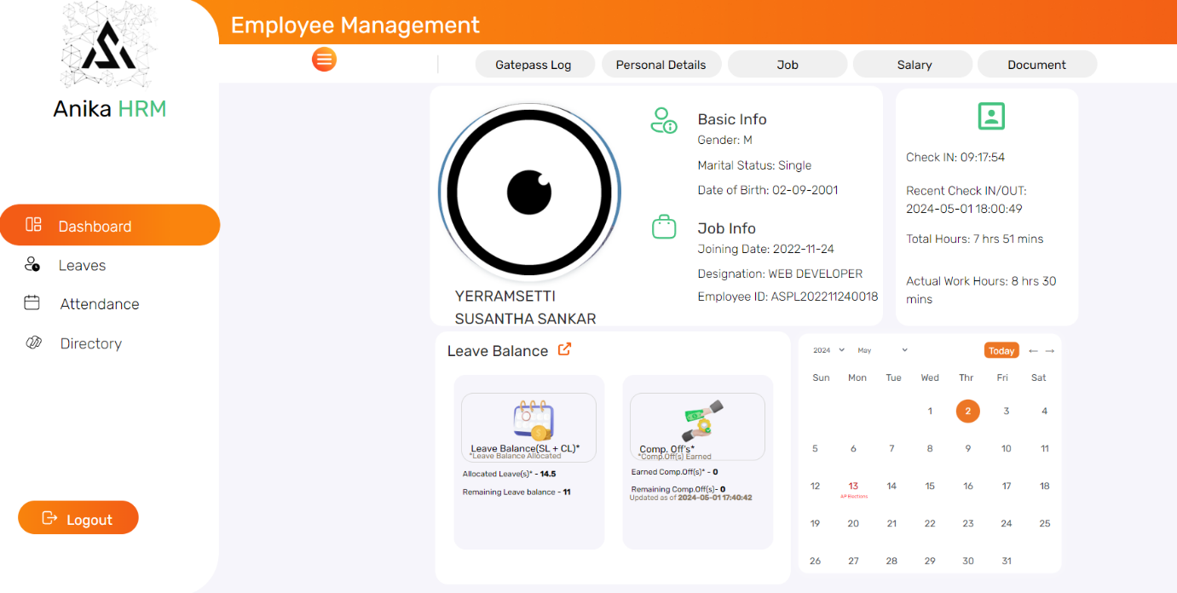

1. Side Bar Elements:

- Dashboard: Provides an overview of essential metrics and updates.

- Leaves: Access your leave management system to request or track leave statuses.

- Attendance: Monitor your attendance records and view attendance-related information.

- Directory: Easily find and access contact information for colleagues.



1

Sidebar

2. Navigation Bar Elements:

- Gatepass Log: Keep track of your gatepass history for entry and exit records.

- Personal Details: View your personal information such as KYC details, contact details.

- Job: Access information related to your job position, responsibilities.

- Salary: View details of your salary, deductions breakdown.

- Document: Access important documents related to your employment.

2

Navigation Bar



3. Dashboard Elements:

- Basic Info: View your basic Info.

- Job Info: Access details about your employee id, department.

- Duty Info: Stay informed about your duty schedule.

- Leave Balance: Check your leave balance to plan time off and ensure compliance with company policies.

- Holiday Calendar: Refer to the holiday calendar to stay informed about upcoming holidays and office closures.

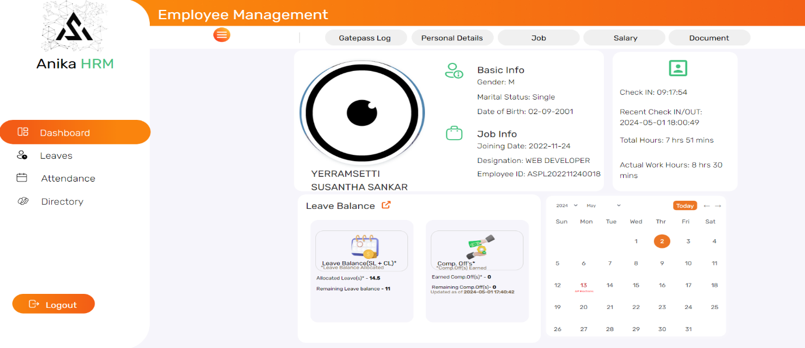

3

By familiarizing yourself with these dashboard elements and functionalities, you can efficiently navigate your dashboard and leverage its features to streamline your HR-related tasks and stay organized in your day-to-day activities.

3. View Past Gatepass Records: Track Your Gatepass History for Reference or Verification Purposes, Ensuring Smooth Access to Premises.

Understanding your gatepass history is crucial for maintaining a record of your access to premises. Here's how you can effectively track and utilize your gatepass history:



1. Gatepass and Gatepass History:

- A gatepass is a document or authorization that grants permission to enter or exit company premises.

- Your gatepass history provides a comprehensive record of all your past gatepass activities, including entries and exits, which is essential for reference and verification purposes.

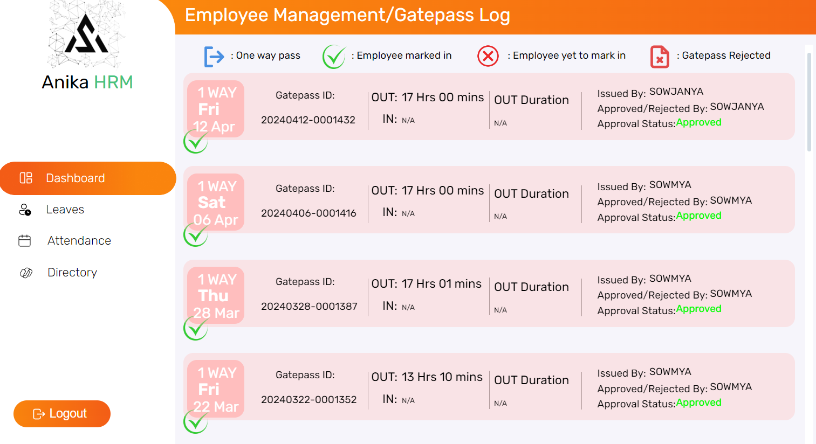

Gatepass Issued Date

2.2

2.1

Gatepass Type

2. Gatepass Log Elements:

-2.1 Gatepass Type (1WAY or 2WAY): Indicates whether the gatepass is for one-way entry/exit or two-way entry/exit.

- Date of Gatepass: Displays the date on which the gatepass was issued or used.

- Gatepass ID: Unique identifier for each gatepass transaction.

- OUT Time and IN Time: Records the time of exit and entry respectively.

- OUT Duration: Duration of time spent outside the premises.

- Issued By: Name or identification of the individual who issued the gatepass.

- Approved By: Name or identification of the individual who approved the gatepass.

- Approval Status: Indicates whether the gatepass was approved or pending approval.

->Click on a gatepass record to view detailed information, including the gatepass type, date, times, durations, and approval status.

->Take note of any discrepancies or issues and report them to the HR if necessary.

-> Use your gatepass history for reference or verification purposes as needed, ensuring smooth access to premises.

By following these steps, you can effectively track and utilize your gatepass history to manage your access to premises and ensure compliance with security protocols.